American University of Sharjah  School of Engineering  Computer Engineering Department  P. O. Box 26666 Sharjah, UAE |  | Instructor: Dr. Ghassan Z. Qadah  Lab Instructor: Ms. Praveena Kolli  Office: EB2-126  Phone: 971-6-515-2352  e-mail: pkolli@aus.edu  Semester: Spring 2019

CMP305L Data Structures and Algorithms
Lab11
Objectives:
- To understand Vertices and Edges
- To implement Graph
Exercise 1
You are developing a Graph program that allows the user to Add vertices and Edges.
- Write a class Vertex as given below:

class Vertex
{
public:
Vertex(); //default constructor
Vertex(string n); //constructor with argument
Vertex( Vertex& a); //copy constructor
Vertex operator=(const Vertex& a)//assignment operator

bool operator == (const Vertex &a)//compares vertices with names only
bool operator != (const Vertex &a); //compares vertices with names only
bool addEdge(string edgeName, int weight);// Adds an edge.
string getName();//return the name
void print()//print vertex name and it’s edges.

private:
string name;
UnsortedType edges;
};

- Write a structure Edge with city name and weight as members.
struct Edge
{
string cityName;
int weight;
Edge()
Edge(string n, int wt)
Edge(Edge& a)
Edge operator=(const Edge& a)
bool operator == (const Edge &a)
bool operator != (const Edge &a)
void print(); //prints cityName and weight.

};
- Update given Unsorted list with info part as a struct Edge, Vertex graph[10];
- Write a main with a declaration of an array of Vertex. Display a Menu to choose the options,
  - Add a Vertex
  - Add an Edge
  - Print the Graph
  - Exit
A sample output is provided.

Conditions should be checked before the action,
- On adding a vertex make sure name of the vertex does not exist in the list.
- On adding the edge make sure that the vertex exist.

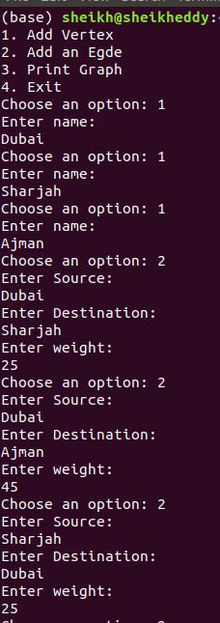
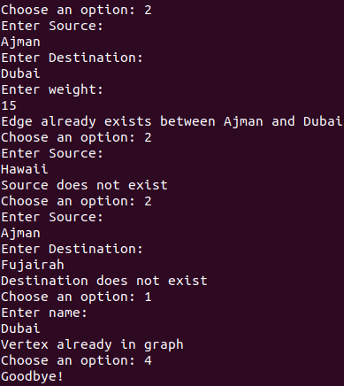
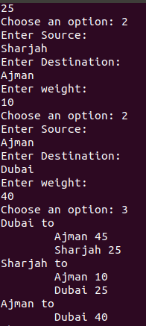

//Vertex.h

#include"UnsortedType.cpp"

class Vertex
{
public:
Vertex(); //default constructor
Vertex(string n); //constructor with argument
Vertex( Vertex& a); //copy constructor
Vertex operator=(const Vertex& a);//assignment operator

bool operator == (const Vertex &a);//compares vertices with names only
bool operator != (const Vertex &a); //compares vertices with names only
bool addEdge(string edgeName, int weight);// Adds an edge.
string getName() const;//return the name
void print();//print vertex name and it’s edges.
bool hasEdge(string edgeName);

private:
string name;
UnsortedType edges;
};

//Vertex.cpp

#include"Vertex.h"
Vertex::Vertex(){ //default constructor
name = "";
}
Vertex::Vertex(string n){ //constructor with argument
name = n;
}
Vertex::Vertex( Vertex& a){ //copy constructor
name = a.getName();
edges = a.edges;
}
Vertex Vertex::operator=(const Vertex& a){//assignment operator

if(this != &a){

name = a.getName();
edges = a.edges;

}
return *this;
}
bool Vertex::operator == (const Vertex &a){//compares vertices with names only
return name == a.getName();
}
bool Vertex::operator != (const Vertex &a){ //compares vertices with names only
return name != a.getName();
}
bool Vertex::addEdge(string edgeName, int weight){// Adds an edge.
Edge e(edgeName, weight);
try{
edges.PutItem(e);
return true;
}catch (std::bad_alloc exception)
{
return false;
}
}
string Vertex::getName() const{//return the name
return name;
}
void Vertex::print(){//print vertex name and its edges.
if(name != ""){
std::cout << name << " to " <<std::endl;

//I do not call ResetList() because GetNextItem loops around
for(int i = 0; i < edges.GetLength(); ++i){
std::cout << "\t";
edges.GetNextItem().print();
}
}
}

bool Vertex::hasEdge(string edgeName){
bool found;
Edge e(edgeName, 0);
edges.GetItem(e, found);
return found;
}

//Non-class functions

const int SIZE = 10;

void displayOptions();
//reminder: arrays are always passed by reference
void makeDecision(int option, Vertex graph[]);
//these functions would be nice if we made Vertex[] iterable
void addVertex(Vertex graph[]);
void addEdge(Vertex graph[]);
bool exists(string a, Vertex graph[]);

int main(){

Vertex graph[SIZE];

int option;
displayOptions();
do{
std::cout << "Choose an option: ";
std::cin >> option;
std::cin.ignore();
makeDecision(option, graph);
}while(option != 4);

return 0;
}

void displayOptions(){
std::cout << "1. Add Vertex\n" \
<< "2. Add an Egde\n" \
<< "3. Print Graph\n" \
<< "4. Exit" << std::endl;
}

void makeDecision(int option, Vertex graph[]){
switch(option){
case 1: addVertex(graph); break;
case 2: addEdge(graph); break;
case 3: for(int i = 0; i < SIZE; ++i){graph[i].print();} break;
case 4: std::cout << "Goodbye!" << std::endl; break;
default: std::cout << "Please enter a valid option" << std::endl;break;
}
}

void addVertex(Vertex graph[]){
std::cout << "Enter name: " << std::endl;
string n;
getline(cin, n);
Vertex v(n);
for(int i = 0; i < SIZE; ++i){
if(graph[i] == v){std::cout << "Vertex already in graph" << std::endl; return;}
if(graph[i].getName() == ""){graph[i] = v; return;}
}
std::cout << "Graph is full!" << std::endl;
}
void addEdge(Vertex graph[]){
std::cout << "Enter Source: " << std::endl;
string source;
getline(std::cin, source);
if(!exists(source, graph)){std::cout << "Source does not exist" << endl; return;}

std::cout << "Enter Destination: " << std::endl;
string destination;
getline(std::cin, destination);
if(!exists(destination, graph)){std::cout << "Destination does not exist" << endl; return;}

std::cout << "Enter weight: " << std::endl;
int wt;
std::cin >> wt;

for(int i = 0; i < SIZE; ++i){
if(graph[i].getName() == source){
if(graph[i].hasEdge(destination)){
std::cout << "Edge already exists between " << source << " and " << destination << std::endl;
}else{
graph[i].addEdge(destination, wt);
}
return;
}
}

}

bool exists(string str, Vertex graph[]){
for(int i = 0; i < SIZE; ++i){
if(graph[i].getName() == str){return true;}
if(graph[i].getName() == ""){return false;}
}
}

//UnsortedType.h

#pragma once
#include <string>
#include<iostream>
#include<limits>
#define ItemType Edge

using std::string;

struct Edge
{
string cityName;
int weight;
Edge(){cityName = ""; weight = std::numeric_limits<int>::max();}
Edge(string n, int wt){cityName = n; weight = wt;}
Edge(Edge& a){cityName = a.cityName; weight = a.weight;}
Edge operator=(const Edge& a){if(this!=&a){cityName = a.cityName; weight = a.weight;}return*this;}
bool operator == (const Edge &a){return cityName==a.cityName;}
bool operator != (const Edge &a){return cityName!=a.cityName;}
void print(){std::cout << cityName << " " << weight << std::endl;} //prints cityName and weight.

};

struct NodeType{
ItemType info;
NodeType* next;
};

class UnsortedType
{

public:
UnsortedType();

UnsortedType(const UnsortedType& orginal);
UnsortedType& operator=(const UnsortedType& orginal);
~UnsortedType();
void MakeEmpty();
bool IsFull() const;
int GetLength() const;
ItemType GetItem(ItemType& item, bool& found) ;
void PutItem(ItemType item);
void DeleteItem(ItemType item);
void ResetList();
ItemType GetNextItem();
private:
NodeType* listData;
int length;
NodeType* currentPos;
};

//UnsortedType.cpp has not been changed

